DEL EMC POWER EDGE R650 SPECS

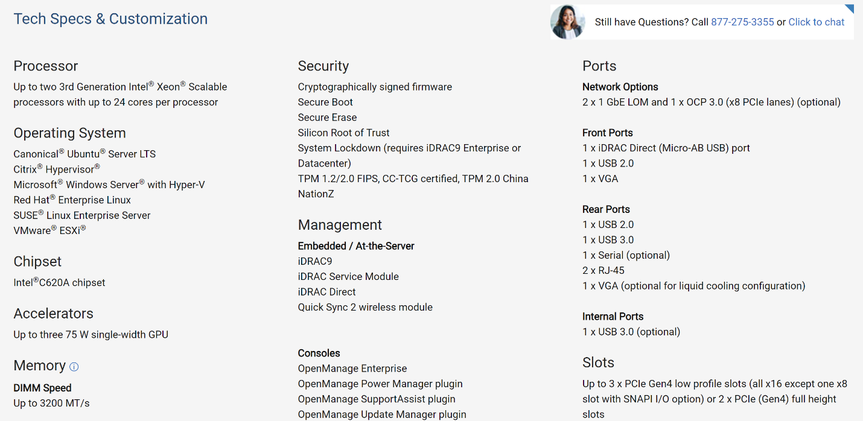

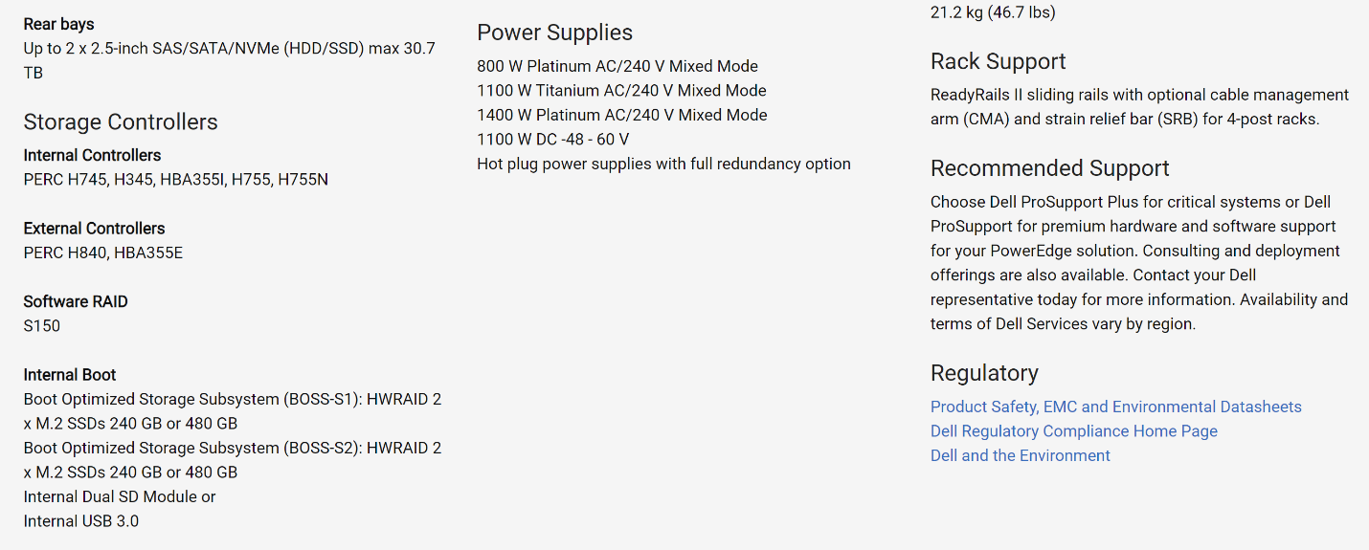

Link: https://www.dell.com/en-us/shop/ipovw/poweredge-r650